SIMATS ENGINEERING
ASSESSMENT TOOL 3

COURSE NAME: OPERATING SYSTEMS COURSE CODE: CSA04

COURSE OUTCOME COVERED
CO2: Analyze process management and deadlock handling techniques to improve CPU utilization and system performance(BL3-BL4)

Assessment Tool Weightage: 30%

QUESTIONS: 10 Total Marks:100

Annexure A
Debugging or Optimization task

Code of Conduct:
I S. Guru Deepika(192572108) (Name / Reg No) certify that this submission is my original work and that I have adhered to the guidelines specified for this assessment.
I understand that any violation of academic integrity rules will result in disciplinary action.

Signature of the student:

Q1. Deadlock Debugging (Code Trace)
You are given the following pseudo-code for two processes sharing resources R1 and R2:
Process P1:
lock(R1)
wait(100 ms)
lock(R2)
critical section
unlock(R2)
unlock(R1)
Process P2:
lock(R2)
wait(100 ms)
lock(R1)
critical section
unlock(R1)
unlock(R2)
Identify the exact condition that causes deadlock.
Suggest an optimisation to eliminate the deadlock without changing process logic.
(10 Marks)

Q2. CPU Utilisation Problem
A system shows low CPU utilisation (30%) even though processes are ready.
You analyse the scheduler log and find frequent transitions:
ready → waiting → ready → waiting → ready ...
Debug the cause using process management concepts and propose a system-level optimisation to improve utilisation.
(10 Marks)

Q3. Memory Bottleneck Debugging
A multi-threaded program frequently encounters page faults, slowing performance. The memory map shows:
- Code: 5 MB
- Heap: 150 MB
- Stack: 1 MB per thread
- 25 threads running
- Physical RAM available: 2 GB
Identify the memory issue causing performance degradation and propose two optimisations.
(10 Marks)

Q4. Starvation Debugging
You observe that process P5 never gets CPU time in a multilevel queue scheduler:
- Q1 (Highest Priority): Interactive
- Q2: System
- Q3: Batch
- Time Quantum: Q1 = 5ms, Q2 = 10ms, Q3 = FCFS
P5 is in Q3 but keeps getting postponed.
Debug the root cause of starvation and suggest an optimisation to ensure fairness.
(10 Marks)

Q5. Context-Switch Overhead Debugging
A server performs 20,000 context switches/sec, causing high overhead.
Log details show:
- Average burst time per thread: 2ms
- I/O wait frequency: very high
- Preemptive scheduler with quantum = 1ms
Explain why context switching is so high and propose two optimisations to reduce overhead.
(10 Marks)

Q6. Producer–Consumer Debugging (Semaphore Error)
A producer-consumer application occasionally hangs after running for several minutes.
Semaphore empty = 5
Semaphore full = 0
Semaphore mutex = 1
Producer:
wait(mutex)
wait(empty)
insert(item)
signal(full)
signal(mutex)
Consumer:
wait(mutex)
wait(full)
remove(item)
signal(empty)
signal(mutex)
The program freezes even though both producer and consumer threads are alive.
1. Identify the synchronization error causing the hang.
2. Explain why the semaphore ordering is incorrect.
3. Suggest the correct semaphore sequence to eliminate the problem.
(10 Marks)

Q7. Thread Performance Debugging
A web server creates one new thread for every incoming client request.
Performance statistics:
• Average requests/sec = 15,000
• Average thread creation time = 0.4 ms
• CPU utilisation = 92%
• Memory usage continuously increases
Developers notice that the server becomes slow after several hours.
1. Identify the thread-management problem.
2. Explain why the current multithreading model causes performance degradation.
3. Propose two optimisations to improve scalability.
(10 Marks)

Q8. Banker's Algorithm Debugging
Available Resources:
A B C = 2 1 1
Allocation:
P1: 1 0 1
P2: 0 1 0
P3: 1 1 1
Maximum:
P1: 2 1 2
P2: 1 2 1
P3: 3 2 2
Process P2 requests (1,1,1).
1. Calculate the Need matrix.
2. Determine whether the request can be granted immediately using Banker's Algorithm.
3. If not, identify the unsafe condition and explain why granting the request could lead to deadlock.
(10 Marks)

Q9. Deadlock Detection and Recovery Debugging
A database server reports that four transactions are waiting for resources.
Resource Allocation Graph:
• T1 waits for R2
• T2 waits for R3
• T3 waits for R4
• T4 waits for R1
• R1 allocated to T1
• R2 allocated to T2
• R3 allocated to T3
• R4 allocated to T4
The database becomes completely unresponsive.
1. Identify whether a deadlock exists.
2. Explain how deadlock detection identifies this situation.
3. Suggest two recovery techniques and justify which one minimises system disruption.
(10 Marks)

Q10. Monitor-Based Synchronization Debugging
A monitor is used to synchronize access to a shared printer.
monitor Printer
{
boolean busy = false;
procedure Print()
{
if(busy)
wait();
busy = true;
// Printing
busy = false;
}
}
Users report that some print jobs never execute even though the printer becomes free.
1. Identify the logical error in the monitor implementation.
2. Explain why waiting processes are never awakened.
3. Modify the monitor logic to ensure correct synchronization and fairn
(10 Marks)
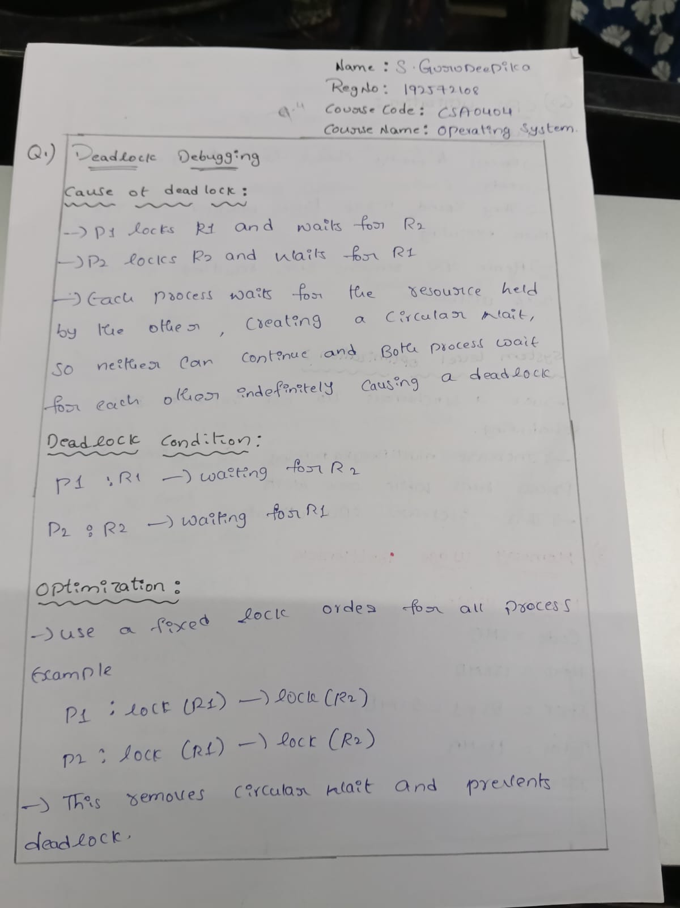
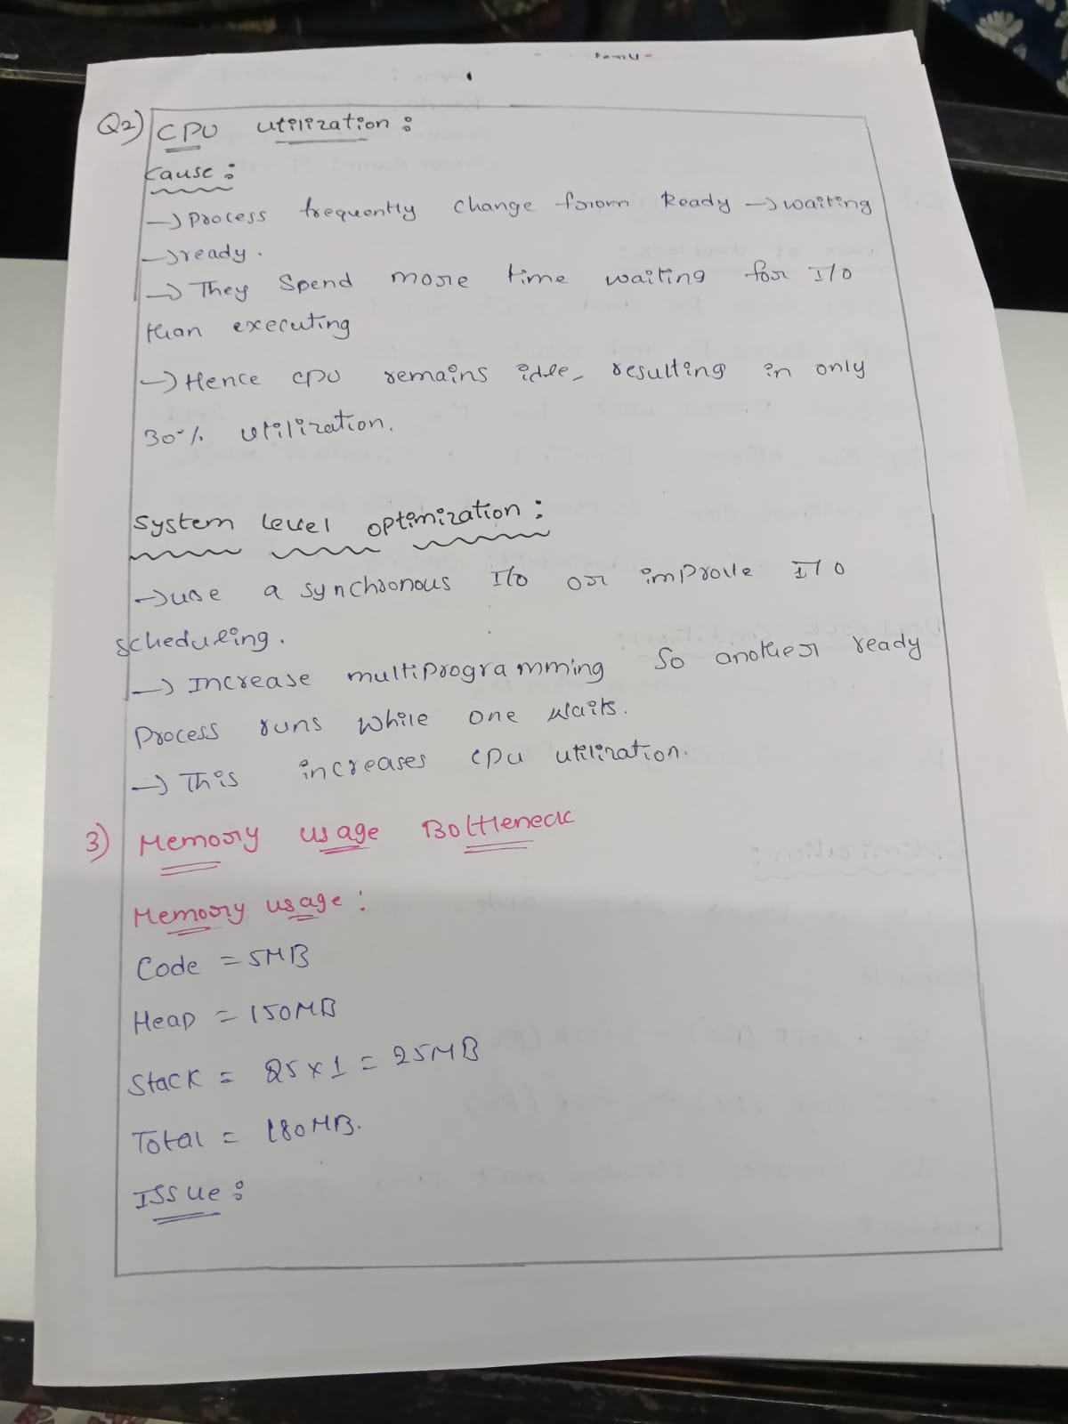
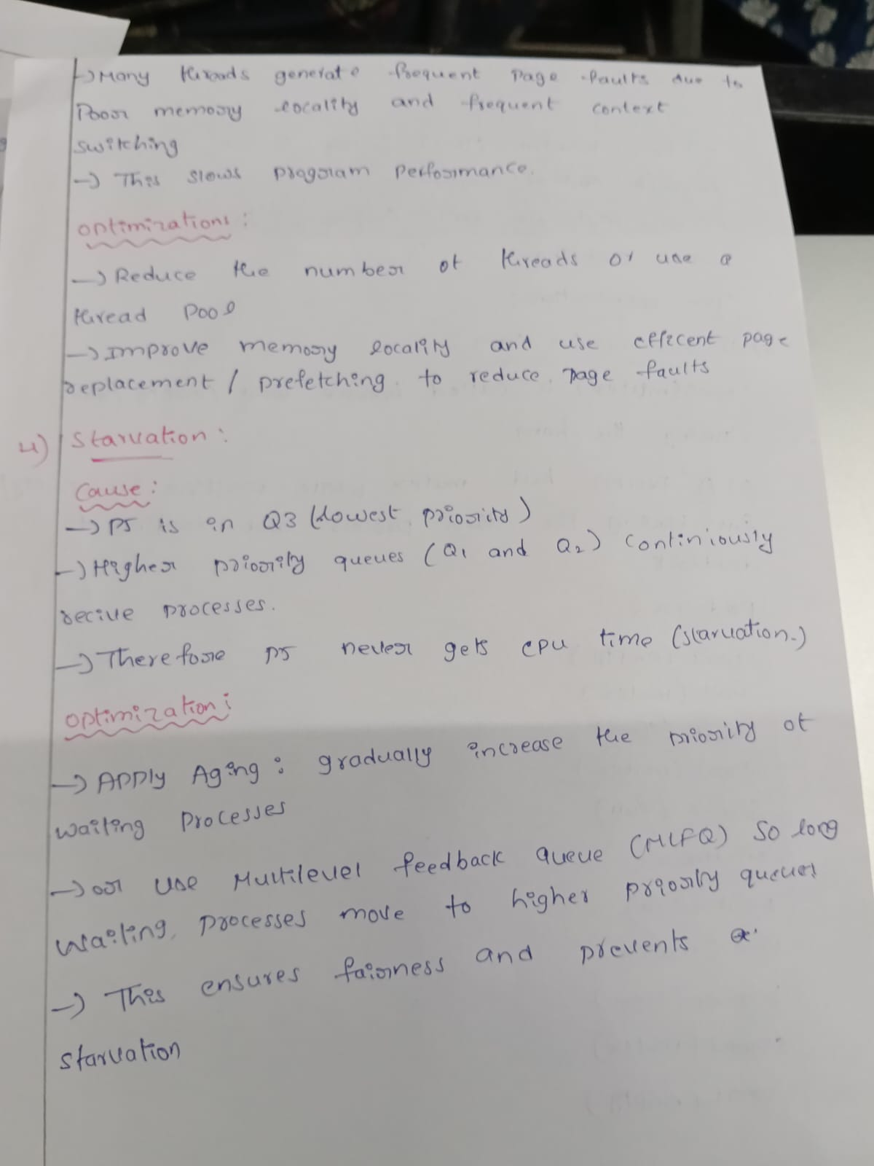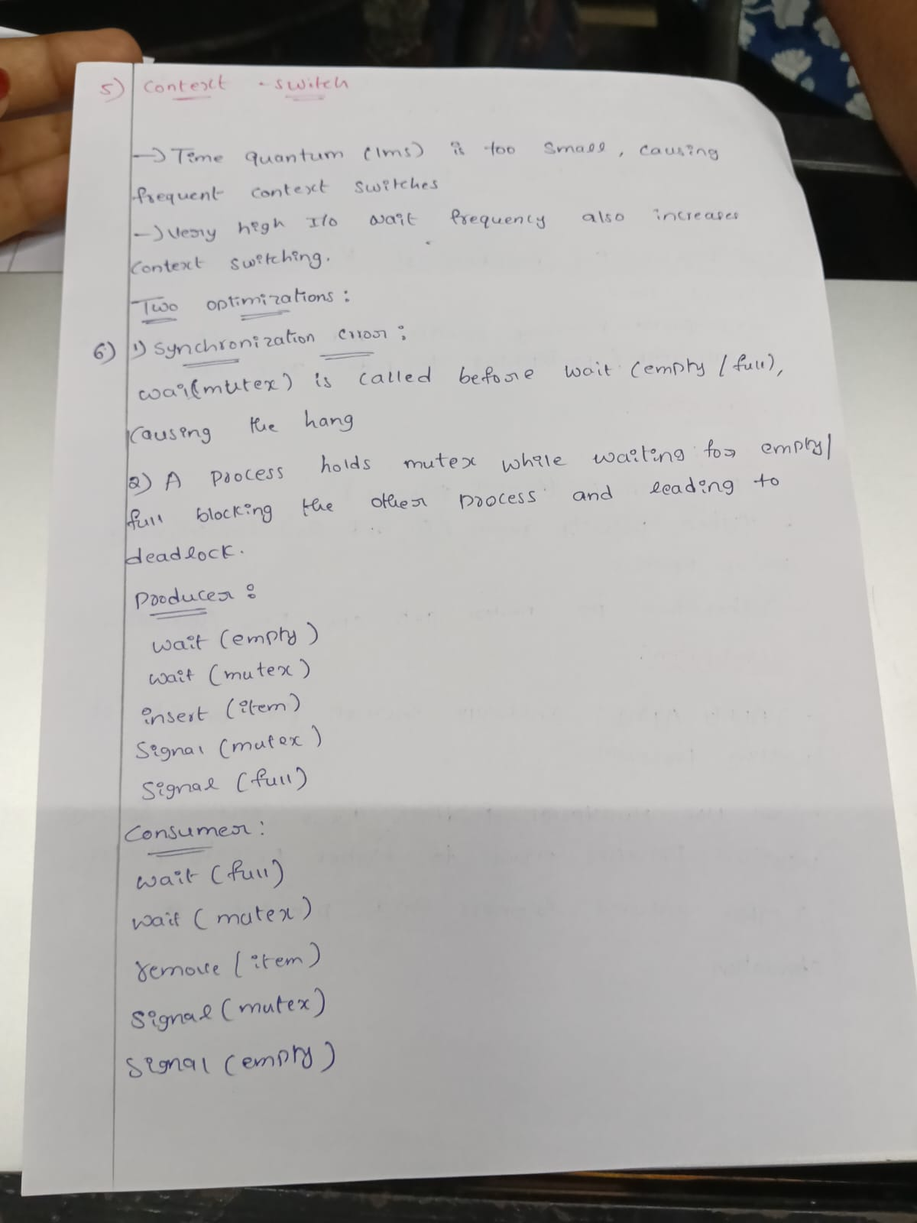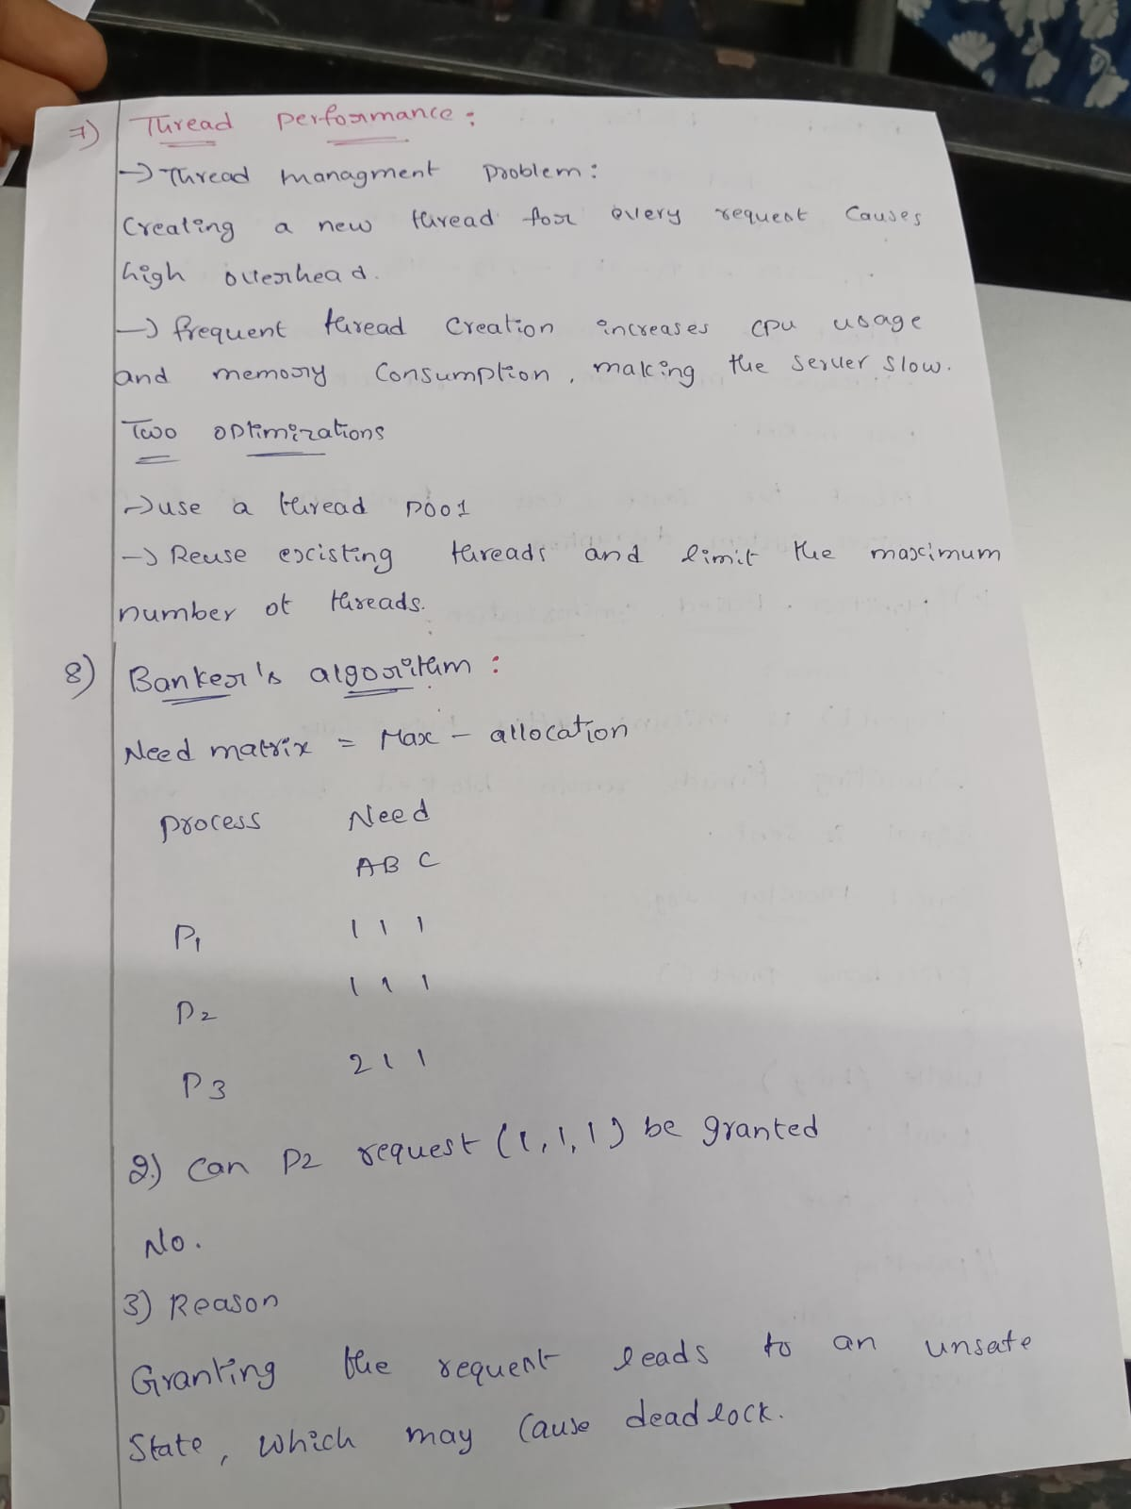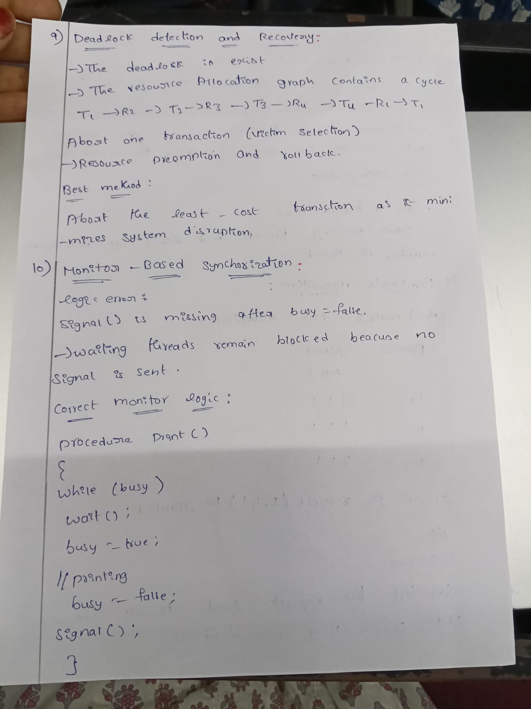

Rubrics for Calculation
Criteria | Weightage | Level 4 (Exemplary) | Level 3 (Proficient) | Level 2 (Developing) | Level 1 (Beginning)
Problem Identification | 20% | Accurately identifies all errors and root causes with clear understanding | Identifies most errors with minor gaps | Identifies some errors but misses key issues | Unable to identify errors correctly
Debugging | 25% | Applies systematic debugging techniques effectively to resolve issues | Uses appropriate debugging methods with minor errors | Limited debugging approach; requires guidance | Unable to debug or resolve issues
Optimization | 20% | Optimizes code by significantly improving time complexity using efficient algorithms | Improves time complexity with minor gaps in efficiency | Limited improvement in time complexity | No improvement; inefficient approach retained
Analysis | 20% | Demonstrates strong logical reasoning and clear justification of solutions | Shows reasonable analysis with some justification | Limited analysis; weak reasoning | No analytical reasoning demonstrated
Code Quality | 15% | Produces clean, well-structured code with proper comments and documentation | Code is mostly clear with minor documentation gaps | Code lacks structure and proper documentation | Poorly written code with no documentation
Marks Evaluation:
Question No. | Problem Identification  (20%) | Debugging(25%) | Optimization (20%) | Analysis (20%) | Code Quality  (15%) | Total Marks  (100)
Q1
Q2
Q3
Q4
Q5
Overall Total (100)

Faculty In-charge | Course Coordinator | Head of Department
Signature: _______________ | Signature: _______________ | Signature: _______________
Date: ___________________ | Date: ___________________ | Date: ___________________

